11.78: a)
b) With respect to the forward edge of the bale, the lever arm of the weight is 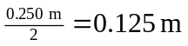 and the lever arm h of the applied force is then h

